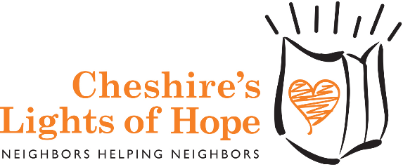

Dear Local Business Owner,
Without the help of local business sponsors like you in our community, Cheshire's Lights of Hope would not have been able to contribute over $770,000 to local charities over the past 12 years. We invite you to join other local Cheshire businesses who support this important event.

This event began as a small, grassroots effort in one neighborhood back in 2005. That year, we wanted to bring our neighborhood together for a common cause. We were so thrilled with the response we received that we decided to continue the tradition while adding more neighboring streets, and in 2007, the event went town-wide.

In twelve years, this event has grown to be a signature Cheshire event - uniting the town and bringing hope for a
brighter future.

Our event has become the one charity that can involve the entire town of Cheshire while keeping the majority of the funds raised in Cheshire. These funds have gone to feed the hungry, to assist those with chronic illness or financial need, and to help deserving students attend college.

This year, the proceeds from the event will go to the Cheshire Community Food Pantry, Cheshire Youth & Social Services, the Petit Family Foundation, the Cheshire’s Lights of Hope Scholarship Fund, and a variety of other local charities.

Our Mission Statement

Cheshire's Lights of Hope unites our community to light up our town and create a brighter world. Through acts of kindness and generosity
we encourage good citizenship and promote volunteerism
while embracing and supporting local charities.

We are proud of how far this event has come and we could not have done it without the support of local businesses and residents. This year, we will be holding our 13th annual event on Saturday, November 11, 2017.

The Mile of Hope is a one mile section in the center of our town that is lit up with over 2,000 luminaries. Hundreds of Cheshire residents and visitors from surrounding towns drive the Mile of Hope each year during the Cheshire’s Lights of Hope event because it is such a unique event in our area.

We are writing to ask your support of The Mile of Hope. We will be placing signs with your company's logo and level of sponsorship along that mile. We will also offer any business not located in that mile 20 luminaries to place in front of their business; please indicate on the attached sponsorship form if you would like us to deliver 20 luminaries to your business.

If you are a new sponsor or your logo has changed, please send a copy of your logo (in jpeg, tiff or gif format to sponsors@cheshireslightsofhope.com, so your logo can be added to our signs and website.

Please review the enclosed form and consider helping us with this wonderful event.

You may contact us with any questions or concerns you may have either by email, info@cheshireslightsofhope.com or by phone (866) 747-9518.

Sincerely,

Don Walsh Kathy Kirby
Don Walsh Kathy Kirby
President Sponsorship Committee Chair
Cheshire’s Lights of Hope
P. O. Box 553
Cheshire, CT 06410
www.cheshireslightsofhope.com

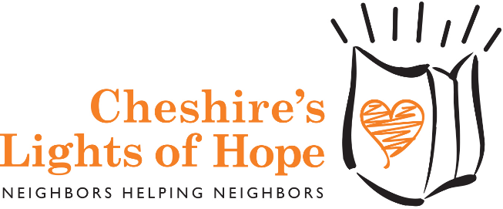

SATURDAY, NOVEMBER 11, 2017

BUSINESS SPONSORSHIP

Company Name:__________________________________________________________________

Contact:_________________________________________Title:_____________________________

Address:___________________________________________________________________________

City, State, Zip:_____________________________________________________________________

Phone:(______)_______________________ Fax:(______) ________________________________

E-Mail: ______________________________Website:______________________________________

Sponsorship Opportunities:

[ ] PLATINUM SPONSOR Cost: $1000 each

[ ] GOLD SPONSOR Cost: $500 each

[ ] SILVER SPONSOR Cost: $250 each
Total enclosed $__________
( ) My business is not located along the Mile of Hope.
Please deliver 20 luminaries to my business.

NEW SPONSORS ONLY - please email us an electronic copy (jpeg,tiff,gif) of your logo: sponsors@cheshireslightsofhope.com

Each sponsor will have a sign placed along the Mile of Hope with their sponsorship level noted.
They will also be listed on our website.

I agree to donate the amount stated above to: Cheshire’s Lights of Hope by Saturday, October 14, 2017.

Signature Title Date

All proceeds will go to:
The Cheshire Community Food Pantry
The Cheshire’s Lights of Hope Scholarship Fund
Cheshire Youth & Social Services
The Petit Family Foundation
And other local charities

Please mail this completed form with your check made payable to:

Cheshire’s Lights of Hope, P.O. Box 553, Cheshire, CT 06410

For more information, please contact us at 866.747.9518 or email: info@cheshireslightsofhope.com

www.cheshireslightsofhope.com

